Music Generation using LSTM

1. Sheet Music
2. ABC Notation
3. MIDI
4. MP3 Files
5. …..

ABC Notation -> Sheet Music -> MIDI Notation

**ABC Notation in MediaWiki**

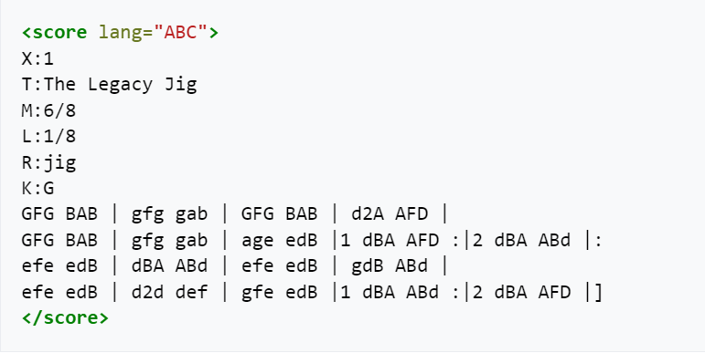

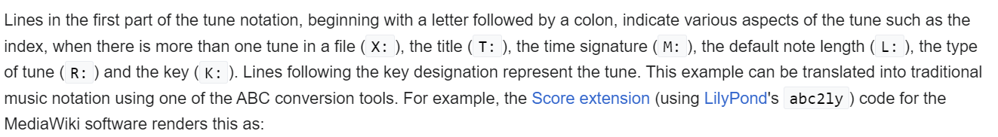

Actual Music 🡪 Represented using Meta Data (Including some colons….)

**ABC Notation 🡪 Sequence of Characters**

Music21 -> Library -> To read MIDI files

**Why not use mp3 format?**

Music composition uses ABC Notation and not composed using Sound much.

Use CharRNN for Music Generation

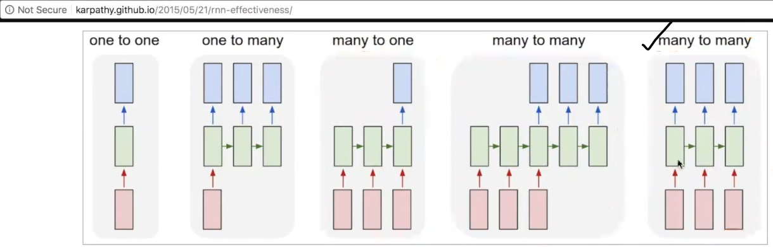

**Char RNN – Many to Many RNN (With One Output for each Input)**

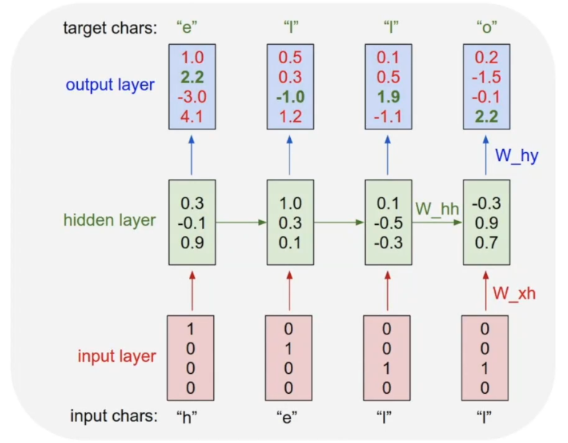

Given some Notations our Model should be able to predict the next Notations.

How the music generation actually works?

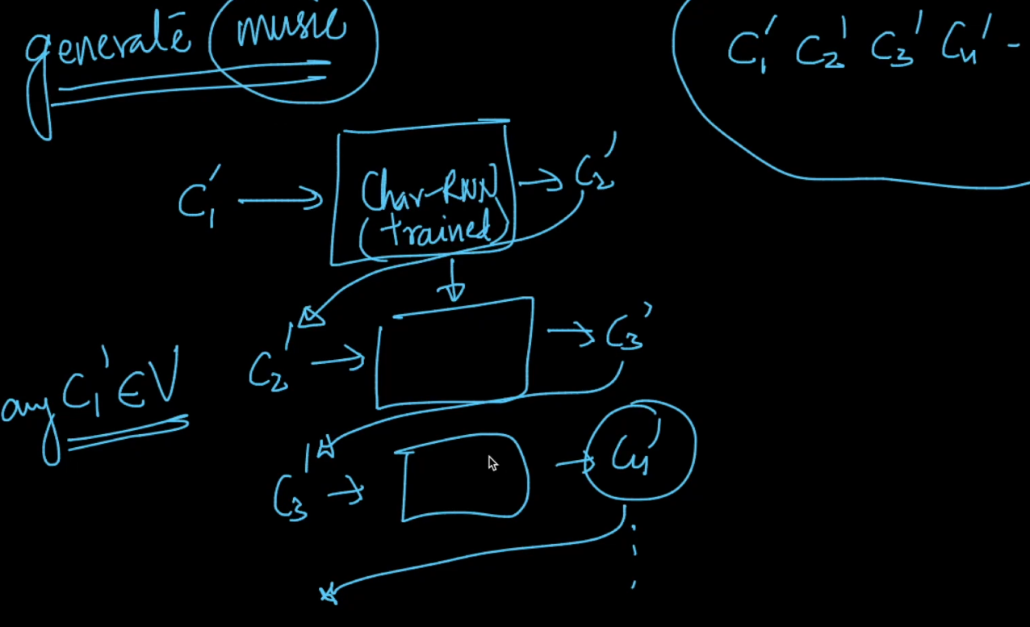

**Data Preparation:   
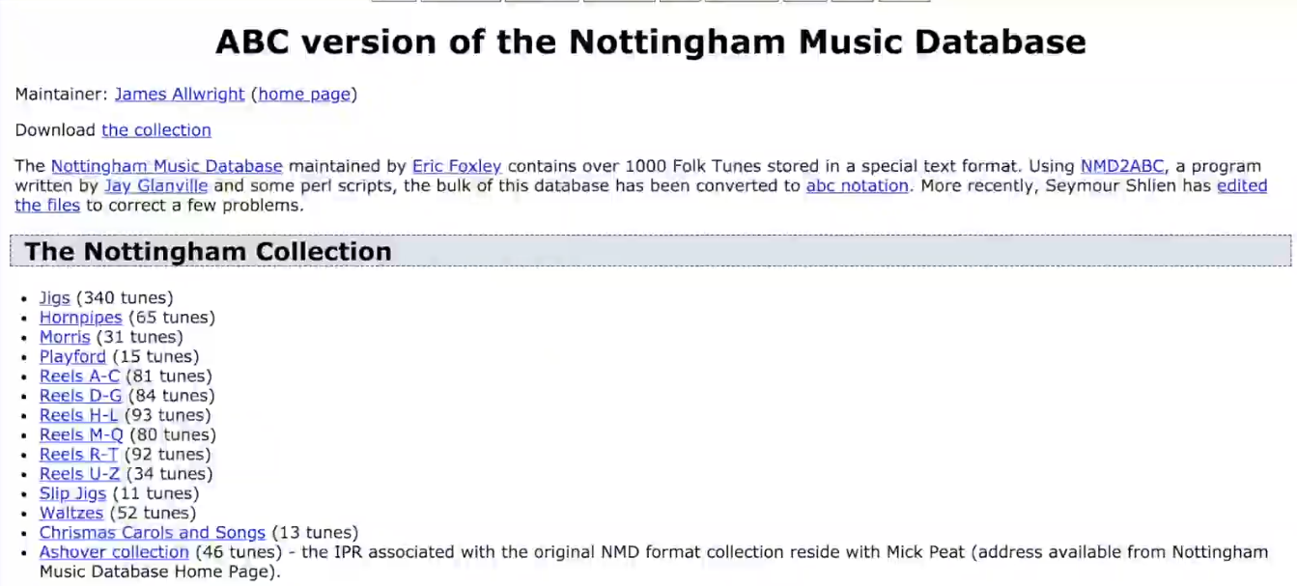**

**For More Data:**

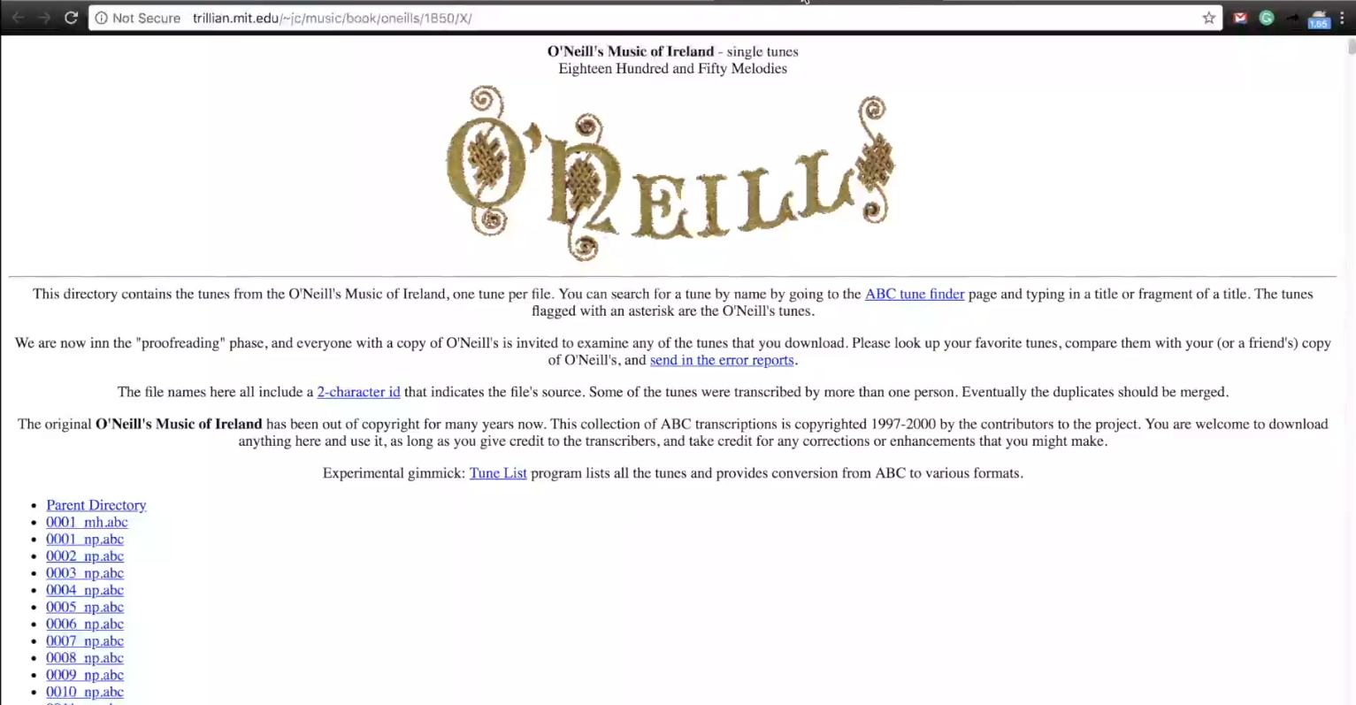

**Pre-Process:**

**Code:**

**Read_batches(T, vocab_size):**

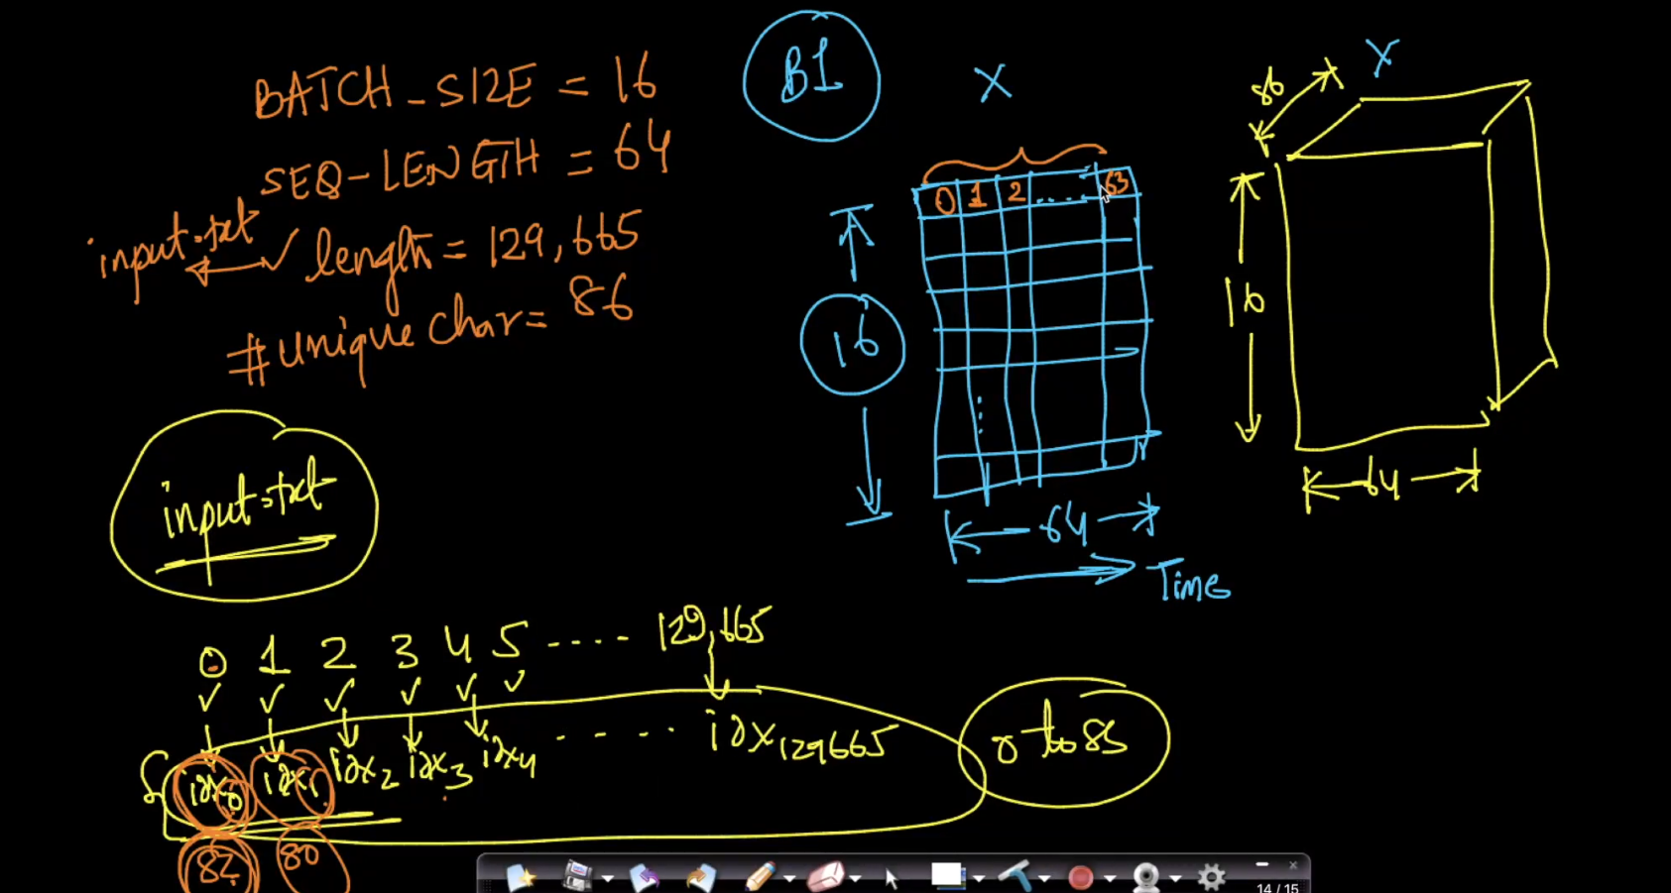

How input and output are constructed:

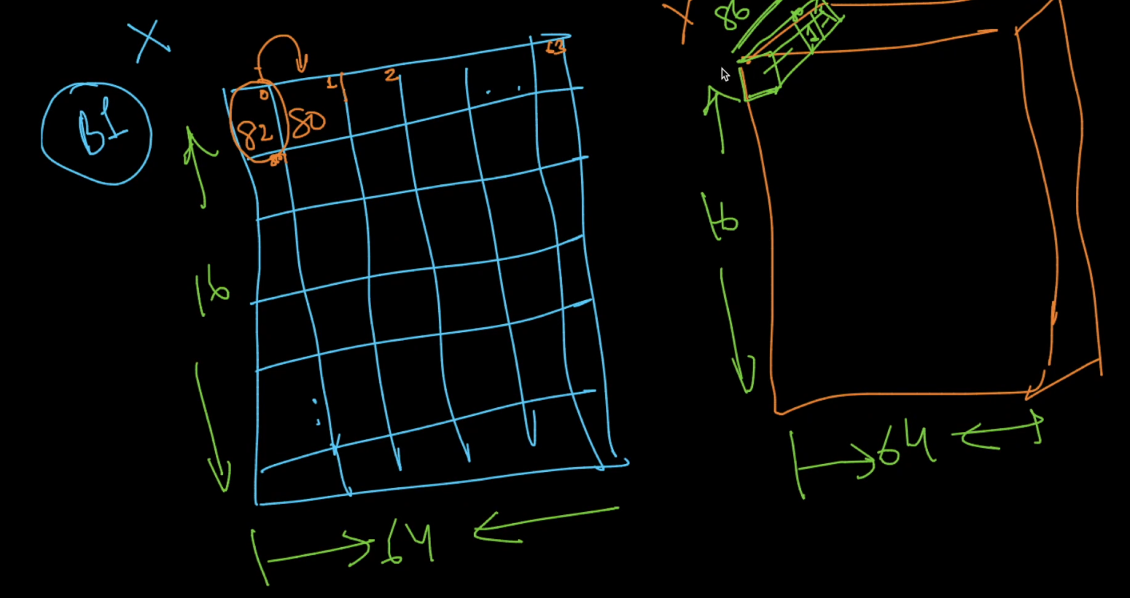

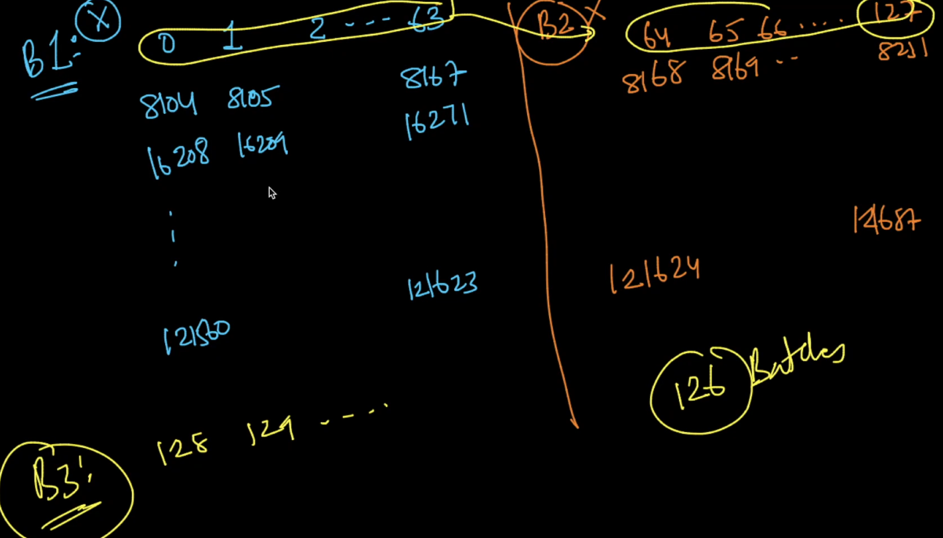

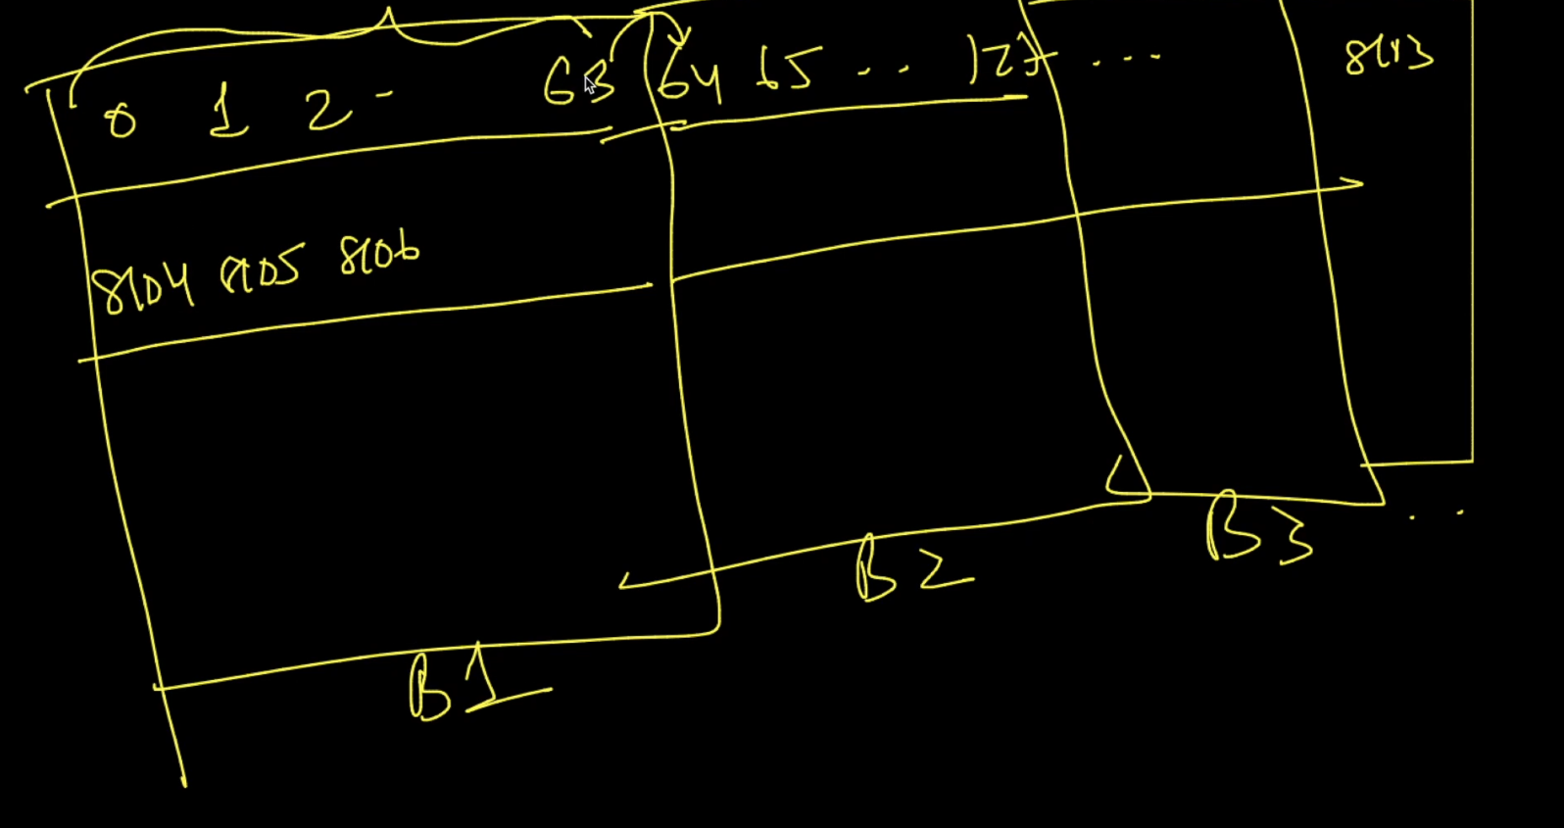

**Architecture:**

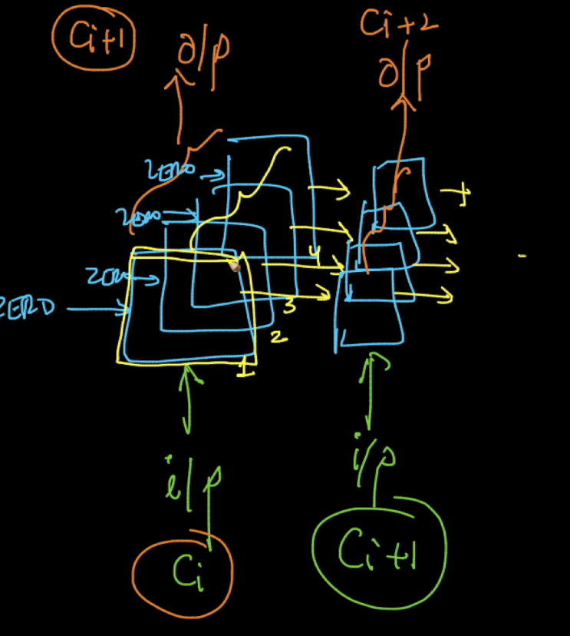

1. **Return_sequences = True (Each LSTM cell returns an output)**
2. **Time Distributed Dense Layer.**
3. **Stateful = True**

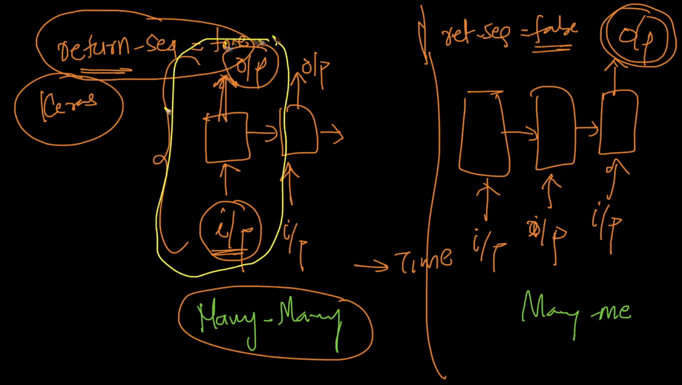

**Time Distributed Dense Layer:  
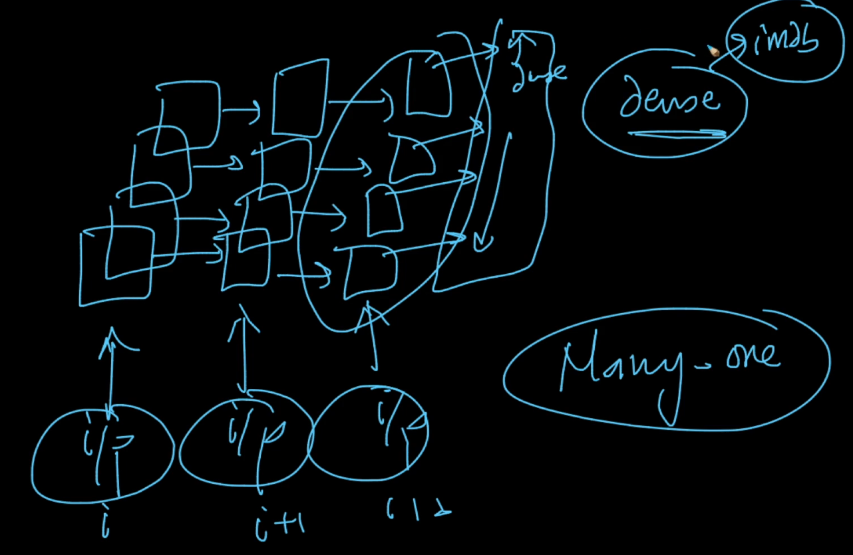**

**Stateful RNN: Weights are conserved for the next batch**

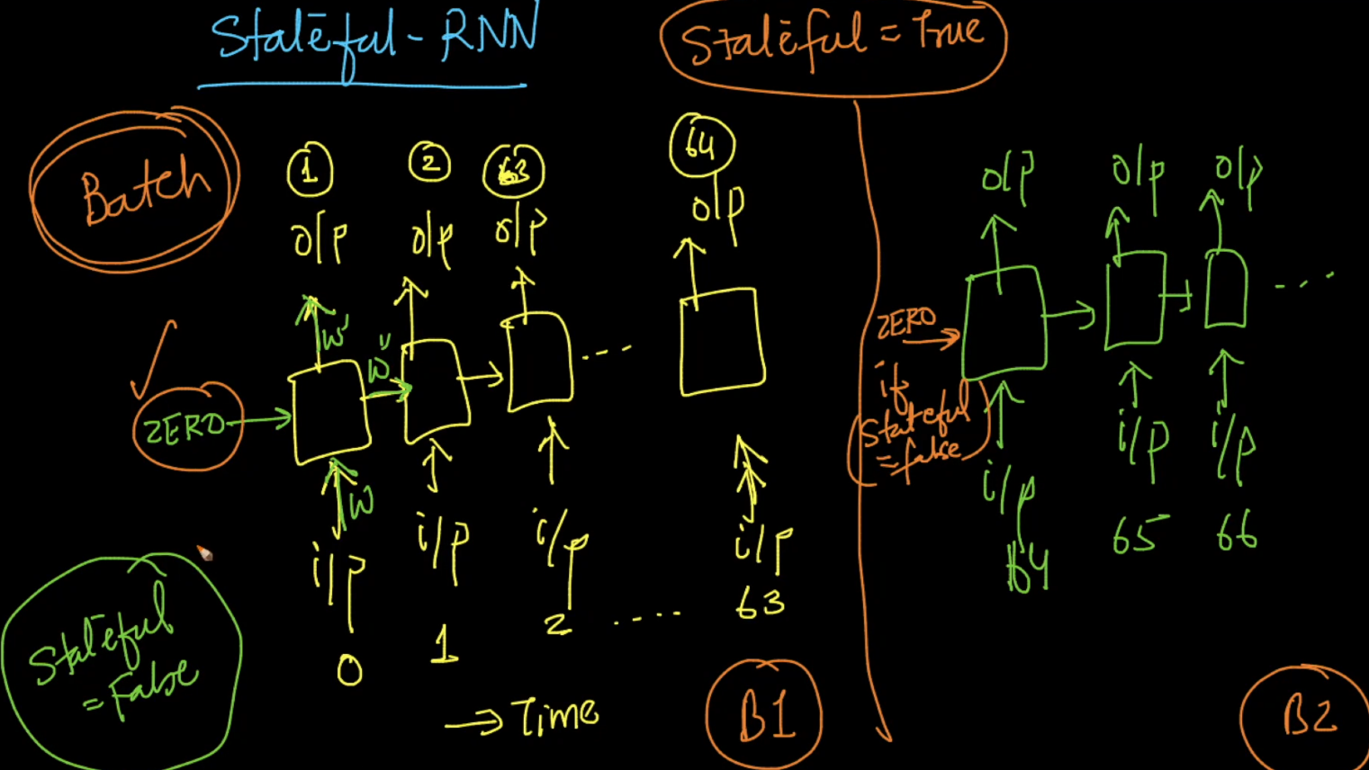

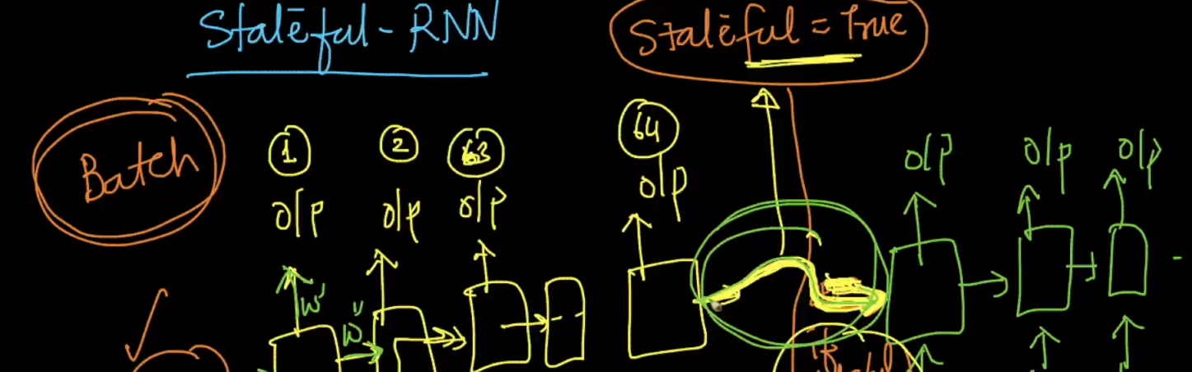

**Code:**

**Train.py**

